How to create a Console Project

Just in case you forgot, here's how to create a Console Project in VS:

1. Right click on the solution and do Add > New Project

2. In Visual C# > Get Started , select Console App

3. Make sure that you set the Console App as a **Startup Project.**This is critical for a Console App project that runs with F5 keyboard shortcut so that the compiler knows where to enter the program.

Just right click on your project and select **Set As Startup Project**. Your project name will become bold like this:

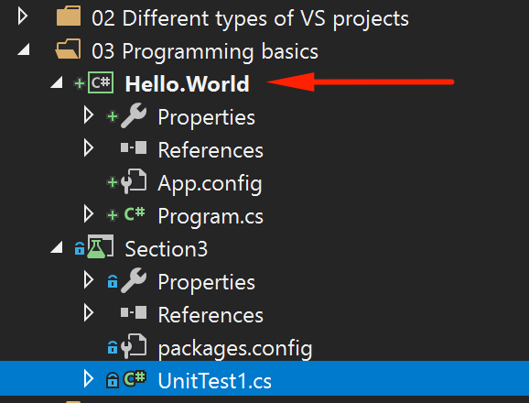

Don't forget to [reference the source code here](https://github.com/nadvolod/CSharpLesons) if for some reason you are getting errors.